Dear Visual Arts Students and Parents,

We would like to welcome you to the Nation Ford High School Art program. Each course has a syllabus outlining specific units of study and requirements, but as a department we have universal expectations and practices. Please read this information and feel free to contact us if you have questions. The information includes; classroom behavioral expectations, discipline procedures and a list of materials you will need.

Throughout the art program, developing a cumulative portfolio is a primary goal. The sketchbook is a way of recording student thoughts both visual and written. A variety of writing and testing methods will be included in all art courses. A new sketch book does not need to be purchased for each course.

We’re always looking for material donations, such as: sharpies, waterproof India ink, cloth/canvas, drawing pencils/colored pencils, paper (all kinds), baby food jars (glass or plastic), watercolors, old towels, magazines, cleaning supplies, hair dryers (we use them as heat guns), plastic containers with lids, paint brushes, laundry detergent, foam trays, egg cartons (foam only) containers, plastic cups and any items you think could be interesting in a Still Life set up such as; old toys, vases, dinnerware, costume jewelry, fabric, etc.
We are always in need of Kleenex tissues and hand sanitizer for all classes.

We have four wonderful teachers in our Visual Arts Department. Feel free to contact any of us with your questions.

Alicia Bagley (bagleya@fortmillschools.org)
Erin Mountain (mountaine@fortmillschools.org)
Holly Gibbs Bentley (bentleyh@fortmillschools.org)
Lindsay Larson (Larsonl@fortmillschools.org)

Extra study/work times are available before school and after school on Tuesdays or by appointment.

Classroom Expectations

- Please enter quietly prepared to work.
- Stay on all art tasks.
- Be considerate of teacher, peers, guests, and materials. Bullying even in the subtlest form will not be tolerated! If it would hurt your feelings or make you uncomfortable then assume it will do the same to someone else. Creating a disruption to other students learning or to the teaching process will not be tolerated. Parents will immediately be informed and the necessary disciplinary actions will be taken.
- Do not go into storage closet or cabinets without permission.
- Always conserve materials.
- Completely clean up your workspace even if it’s not your mess.
- Defacing materials, class supplies, work surfaces, etc. is destruction of public property and will be written up.
- Be silent during announcements and in seat until bell rings once you have cleaned your space and materials.
- No cell phones in class. Cell phones should not be seen or heard at any time. This also includes the use of headphones/earbuds.

Consequences of inappropriate behavior will be:
1. Warning
2. Conference with student or call home
3. Referral
* Failure or refusal to participate in clean up daily and/or on cleaning days will result in a lunch detention and if persists will lead to more sever disciplinary actions.*
* Cell phones will be dealt with in accordance to school policy.
Required Materials for Drawing 1
- 8” x 11” Spiral Bound Sketchbook (this is the minimum size)
  - I would recommend spiral on the left side, they last a lot longer and are more durable.
- Drawing pencils – 4H, 2H, HB, 2B, 4B, 6B (feel free to purchase more)
- Blender/paper stump/tortillion (several will be needed)
  - They come two ways: hollow and solid. Solid are more durable
- Erasers (several cap erasers too)
- Handheld pencil sharpener with cap or closure to store pencil shavings (very important)
- Colored Pencils
  - A 12 count of Crayola would work but 24 count would help them more, (the more colors the better). (Do not get the erasable kind- they do not blend well).
  - If you want to splurge Prisma color is the best quality available but are more expensive. Scholar is a good compromise but again not necessary.
  - Avoid cheap brands at all cost (rose art, craz art, artist loft, etc.)
- A small container to store loose supplies in. (shoebox will work fine).
- A small amount of sand paper or sheet of sandpaper.

Suggested Materials (not required but having their own may be beneficial on certain projects).
- 12” or 18 “ wooden ruler (I have some but the numbers are rubbing off)
- Ultra fine/ Fine Sharpies (black) one each
- Chalk or oil pastels
- Charcoal pencils
- Willow charcoal
- Colored Pencil Blender
  - (Pencil or marker-pencil last longer found specifically at Michaels and Hobby Lobby. There is an entire set at Walmart for 12.99 but you can find an individual one for about 2-4$

Suggested Retailers:
Michaels, Hobby Lobby, Binders, Wal-Mart, Office Depot, Staples, Big Lots, Cheap Joe’s Art Supplies, and Target.

Weekly communication:
Rather than send out weekly emails I send out reminds on a regular basis alerting of timelines and due dates. In addition to Remind, last year I started my own website for the students and have all the PowerPoints on that page as well as a blog for each homework assignment as they arrive. This website is linked to my Nation Ford Page but I wanted to give you the address here as well it is bagleysartroom.weebly.com.
This year I will also be using the Remind app to help communicate information to you and your child. Remind works by sending a text message and/or email. I am requiring each of my student to sign up. If your child does not have a cell phone or if you would prefer for information to be sent only to you, then you may use your number to sign up as well or instead of. I will not have access to your or your child’s cell phone number, nor will they have access to mine using this app. All personal information is kept private. There are directions on how to sign up on the front and back of the signature page of the Parent/Student contract. Please ONLY sign up for the class your child is in, otherwise you will receive information for the wrong class. I highly recommend that you and your child sign up for remind so that you both are consistently aware due dates as this will be my main source of communication.

Please sign and return JUST the bottom portion:

By signing this contract you are stating that you have read, understand and agree with the expectations and consequences of my classroom.

Student name______________________________ Student signature __________________________

Parent name_______________________________ Parent signature_____________________________

Please provide the following information you prefer for me to use to contact you. Please emphasize which method of communication you prefer. (This information will be used so that I may communicate with you on an individual basis as opposed to mass emails or texts via Remind)
- parents e-mail____________________________________________
- home phone________________ parents work phone_______________
- other (cell phone, alternate contact)___________________________

My child and I will be signing/have signed up for Remind.

Only I will be signing up for Remind.

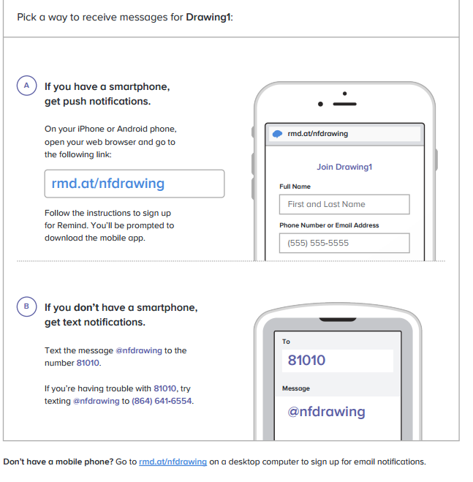

Drawing 1 Syllabus
Nation Ford High School
Miss Bagley

The purpose of this course is to introduce the student to art vocabulary and to develop basic drawing skills. Students will learn and utilize different drawing techniques and different media. Students will develop an understanding of the history of drawing.

Expectations:
Students will be expected to work in a cooperative and collaborative manner with other students and the teacher.
Develop an appreciation for the work of others and respect the work place of others. Learn to maintain an efficient and organized classroom studio.
Manage their time appropriately.
Maintain an ongoing cumulative sketchbook during the semester for homework.

This class is not based on skill. I understand that many students are in this class for their fine arts credit, however each student must meet the objectives assigned and put forth effort. Failure to do this will result in a below average grade.
Grading:
The student will be graded on projects, writings, daily work, and sketchbooks, based on the class rubric (see rubric for more info) and/or participation.
- 15% Sketchbook (homework, sketches, etc.)
- 35% In Class Activities (quizzes, critiques)
- 50% projects (major works of art)

Late policy-4 points will be deducted on any assignment for every day it is late excluding weekends. Students have two weeks after the due date to turn it in.
*sketchbooks have a different late policy
** Artist statements will not be accepted late at all

No work will be accepted after that 6 weeks is up
**All finished work must be turned into the basket on my desk, I will not search through your in progress work***

Retest policy- If you are unsatisfied with your project grade (only) you may be given the opportunity to re-work it with my approval and the original rubric within that six weeks. Bad grades on quizzes or sketchbooks will not be adjusted.

Theft Policy- It is the students’ responsibility to keep all valuable items on them at all times. The teacher will not be held responsible in the case of theft and will not interrupt class if a situation of this nature will occur.

Bathroom policy- Students will be given two passes each six weeks and will only be allowed to use them for the bathroom unless provided with a parent note. It is the students’ responsibility to take care of personal issues before coming to my class. In order to use the restroom the students’ cell phone will need to be left with the teacher.

Tardy Policy- Students are expected to be in their seat with ALL supplies by the time the tardy bell rings or will be sent to ISS for being tardy. Students need to come in and start on the bell work.

Sketches/Homework
Sketches will be required for each project. All sketchbook assignments will be done as homework and will be given a due date. Late sketchbooks will not be accepted more than one day late and will have a 5 point. There will be a sketchbook/homework assignment due every other week. Failure to complete these assignments will dramatically impact the student’s grade. A list of weekly assignments will be administered and available online.

Quizzes and Critiques
Students will be assessed in a variety of ways in Drawing I. Quizzes will be given on information provided in class, this will include drawing terms, concepts, techniques, and history. Each project will be followed by a critique in which students are expected to discuss their work and the work of their peers. Students will be required in an Artist Statement, for most projects, that reflects upon their process and results.

Overarching Goal: Criticism – Describe, Analyze, Interpret, Judge - Art

Unit 1 :Elements and Principles (Contour project, Abstract Design, Value Project)
Unit 2: Color Theory (Color pencil Still life, Color Scheme practice)
Unit 3: Perspective (1 point, 2 point, atmospheric)
Unit 4: Portraits (Ipad Portrait, Mirror Image, Mixed Media)
Unit 5: Conceptual (Research Project)

This syllabus is subject to change. We must be flexible in our lives as well as in our classroom.

For more information and for PowerPoints please visit: bagleysartroom.weebly.com

